5. Plot of Small Circles in Various Projections

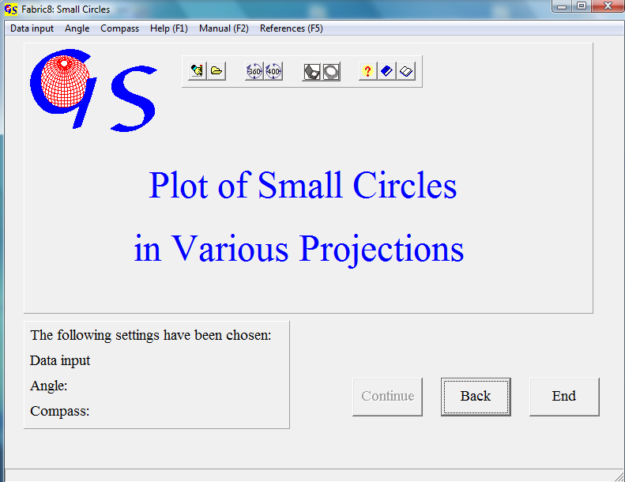
Fig.. 1

This programm (Fig. 1) calculates and plots small circles with the projec-tions which are also used in the other programs.
Data input can be manually or from a file. Manual input of the axes to the small circles can be either the readings of a Clar or of a Brunton compass (Fig.2).

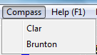
Fig. 2

Clar compass : Azimuth of plunge and plunge angle,
Brunton compass: Strike, plunge angle, and plunge direction.

Fig. 3 shows the form for manual data input in the Clar compass format
(Azimuth of plunge, Plunge angle).
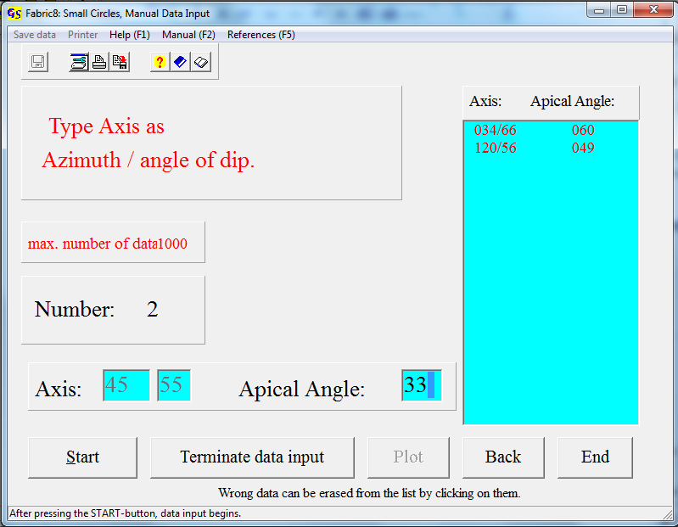 Fig. 3

Fig. 4 shows the form for manual data input in the Brunton compass format ( Strike of plunge, Plunge angle, direction of plunge).

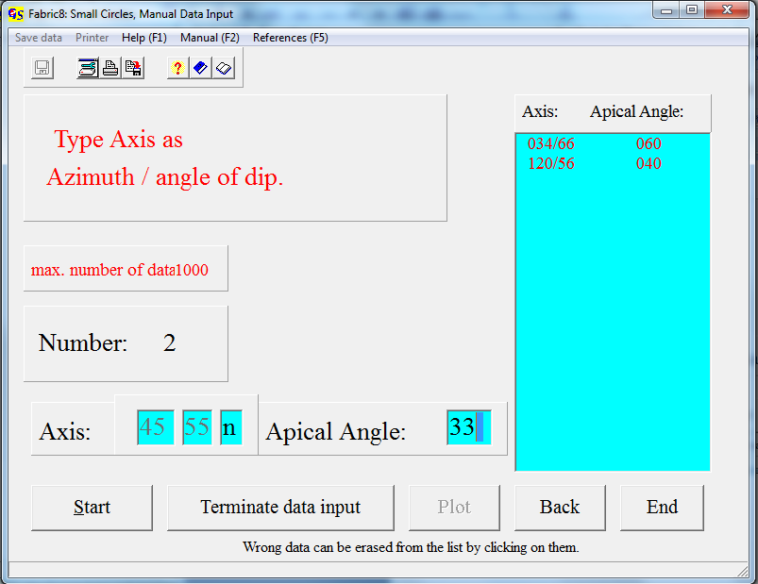
Fig. 4.

The button “Terminate input” brings you to the graphic form, shown in Fig. 5

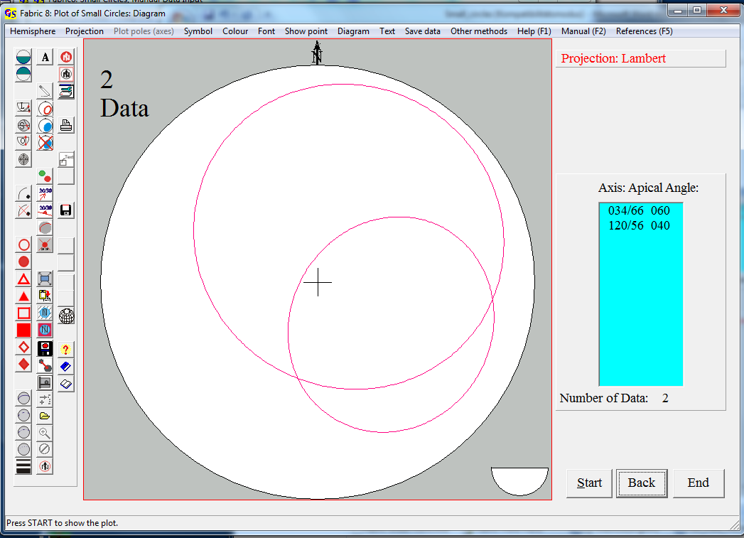
Fig. 4

In the menu “Colour” (Fig. 5) you can choose the colour of the circle, and you can also fill the circle with a colour (Fig. 6), or erase the filling.

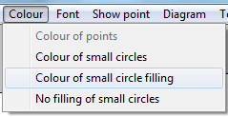
Fig. 5
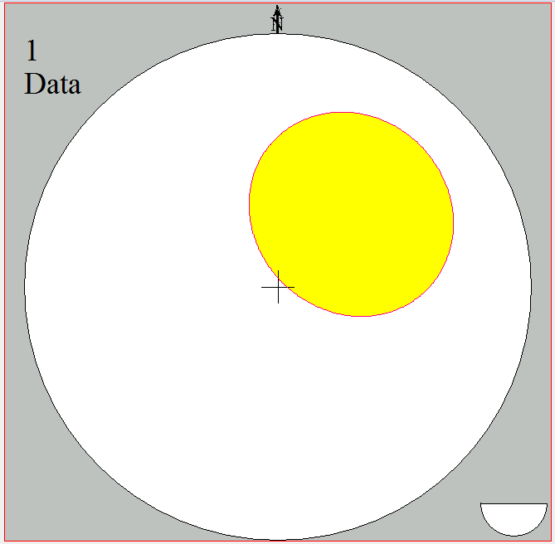
Fig. 6

With the menu “Other methods” (Fig. 7) you can jump to the program “Projection of a sphere”.

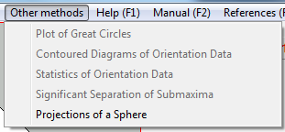
Fig. 7

The other menus are described in program 3.

